**CO4 PROGRAMS**

**1. Create Rectangle class with attributes length and breadth and methods to find area and**

**perimeter. Compare two Rectangle objects by their area.**

***Input:***

class Rectangle:

def __init__(self,length,breadth,ar):

self.length=length

self.breadth=breadth

self.ar=0

def area(self):

self.ar=self.length*self.breadth

#print("area=",self.ar)

return (self.ar)

def perimeter(self):

self.perimeter=2*(self.length+self.breadth)

#print(perimeter)

return (self.perimeter)

def display(self):

print("area=",self.ar)

print("perimeter=",self.perimeter)

R1=Rectangle(2,4,0)

R2=Rectangle(3,4,0)

R1.area()

R1.perimeter()

R2.area()

R2.perimeter()

print("Area of Rectangle1")

R1.display()

print("Area of Rectangle2")

R2.display()

if (R1.ar>R2.ar):

print(R1.ar,"is graeter")

else:

print(R2.ar,"is greater")

***Output:***

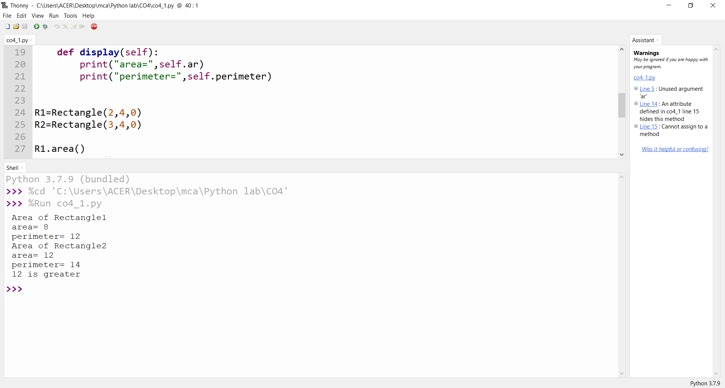

**2. Create a Bank account with members account number, name, type of account and balance.**

**Write constructor and methods to deposit at the bank and withdraw an amount from the bank.**

***Input:***

class Bank:

def __init__(self,bal=0):

#self.accno=accno

#self.name=name

#self.acctype=acctype

self.bal=bal

name=input("Enter name : ")

print(".....Account for",name,"is created.....")

def deposit(self):

amount=int(input("Amount to deposit : "))

self.bal=self.bal+amount

print("New balance:",self.bal)

def withdarw(self):

amount=int(input("Amount to withdraw : "))

if(self.bal>amount):

self.bal=self.bal-amount

print("New balance:",self.bal)

else:

print("....Insufficient Balance....")

print("Current balance : ",self.bal)

def display(self):

print("Current Balance:",self.bal)

print("..........Account..........")

b1=Bank()

opt='y'

while(opt=='y'):

#print("your choice: 1. deposit \n 2. withdarw \n 3. display\n")

choice=int(input("Choices are: \n1. Deposit\n2. Withdarw \n3. Display\n\nEnter your choice: "))

if(choice == 1):

b1.deposit()

elif(choice==2):

b1.withdarw()

elif(choice==3):

b1.display()

else:

print("Invalid Choice")

opt=input("Do you want to continue? (Enter 'y'/'n') : ")

***Output:***

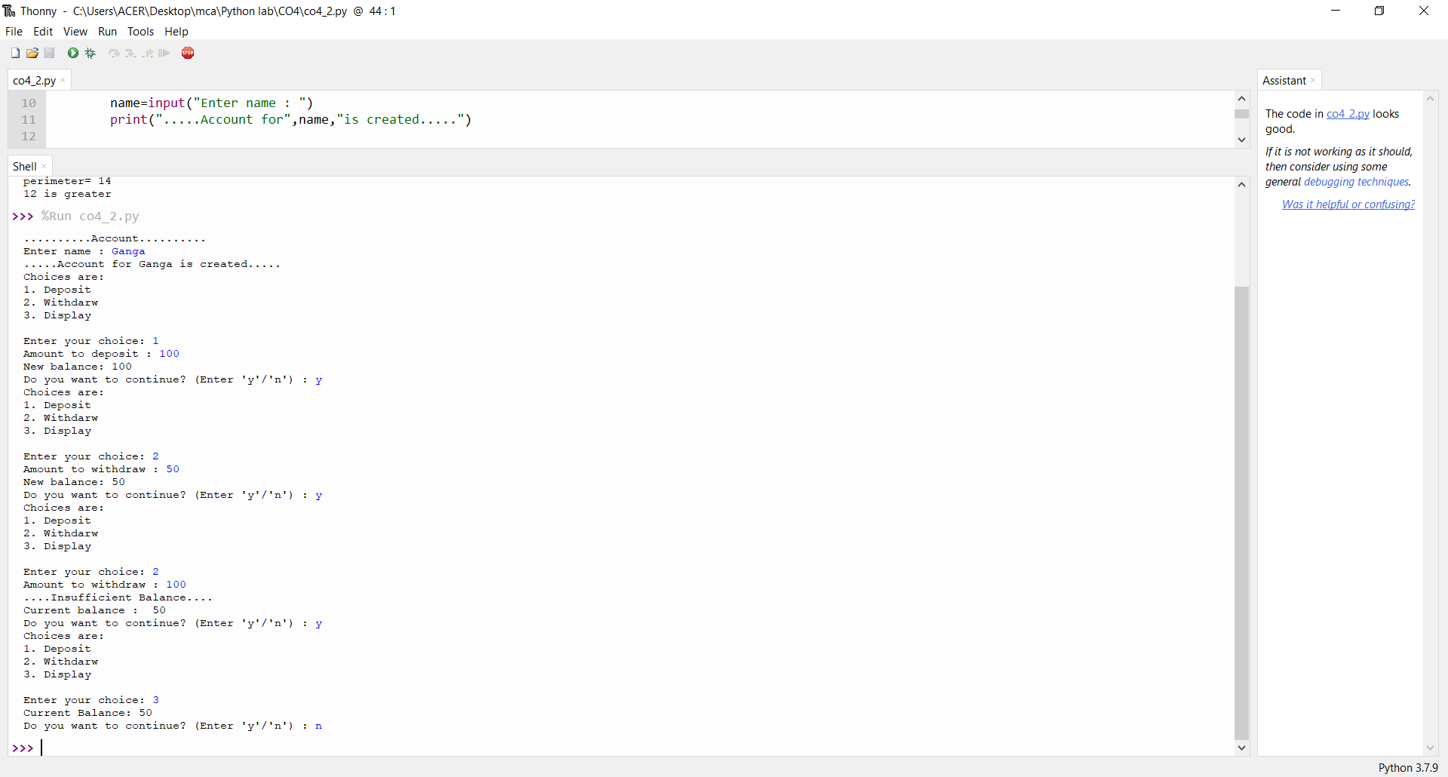

**3. Create a class Rectangle with private attributes length and width. Overload ‘<’ operator to**

**compare the area of 2 rectangles.**

***Input:***

class rectangle:

def __init__(self,length,width):

self.length=length

self.width=width

def __lt__(self,a2):

area1=self.length*self.width

area2=a2.length*a2.width

if(area1<area2):

return(True)

else:

return(False)

print("Enter the Details of Rectangle:1")

l1=int(input("Length : "))

w1=int(input("Width : "))

r1=rectangle(l1,w1)

print("Enter the Details of Rectangle:2")

l2=int(input("Length : "))

w2=int(input("Width : "))

r2=rectangle(l2,w2)

if(r1<r2):

print("Rectangle 2 is larger!!")

else:

print("Rectangle 1 is larger!!")

***Output:***

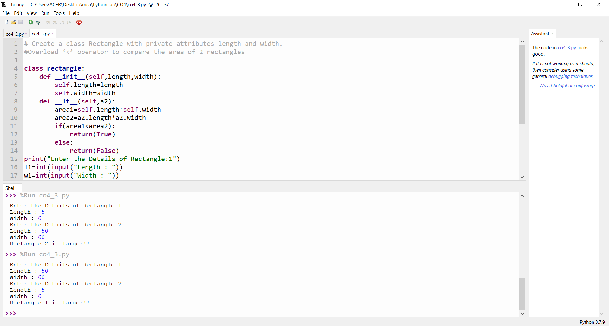

**4. Create a class Time with private attributes hour, minute and second. Overload ‘+’ operator to**

**find sum of 2 time.**

***Input:***

class Time:

def __init__(self,hour,minute,second):

self.hour=hour

self.minute=minute

self.second=second

def __add__(self,a2):

second=self.second+a2.second

minute=self.minute+a2.minute

hour=self.hour+a2.hour

if(second>60):

second=second-60

minute=minute+1

if(minute>60):

minute=minute-60

hour=hour+1

return hour,minute,second

print("Enter time1 : ")

h1=int(input("hour : "))

m1=int(input("minute : "))

s1=int(input("second : "))

t1=Time(h1,m1,s1)

print("Enter time2 : ")

h2=int(input("hour : "))

m2=int(input("minute : "))

s2=int(input("second : "))

t2=Time(h2,m2,s2)

hr,min,sec=t1+t2

print(hr,end=":")

print(min,end=":")

print(sec,end=" ")

***Output:***

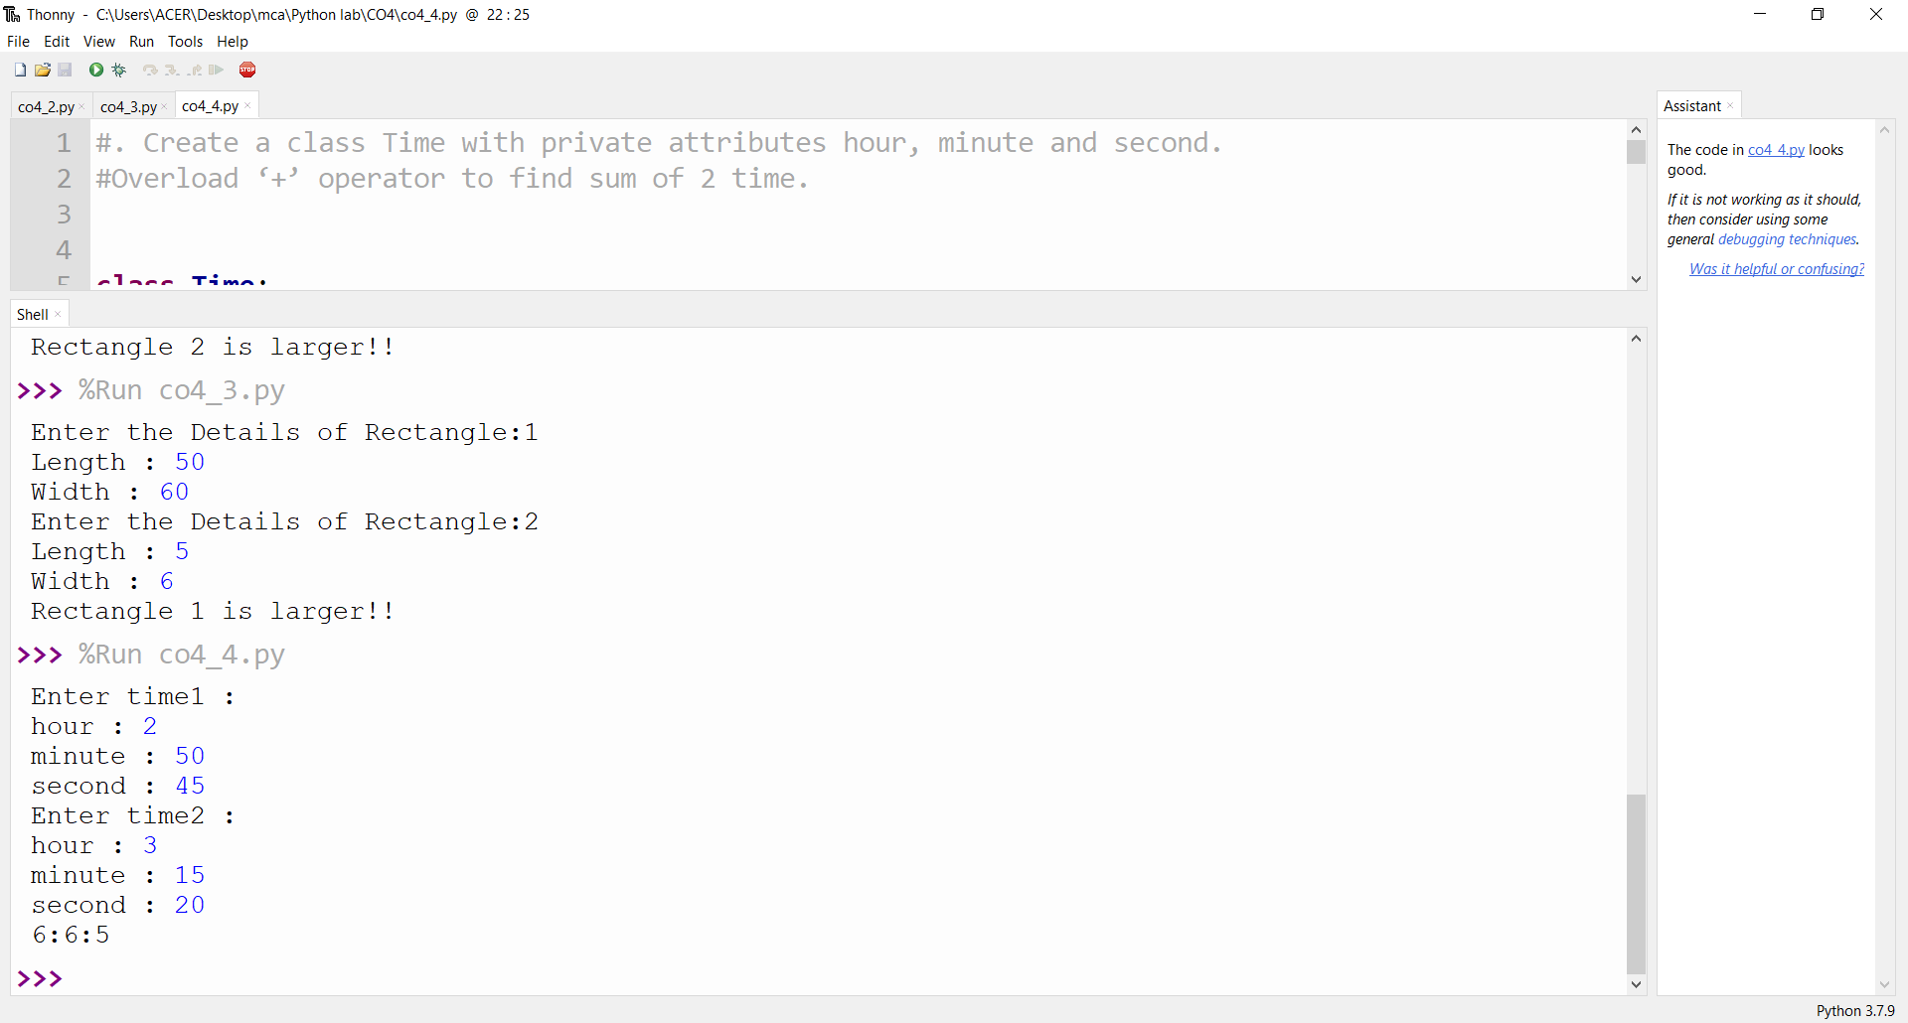

**5. Create a class Publisher (name). Derive class Book from Publisher with attributes title and**

**author. Derive class Python from Book with attributes price and no_of_pages. Write a**

**program that displays information about a Python book. Use base class constructor invocation and**

**method overriding.**

***Input:***

class publisher:

def __init__ (self,pn):

self.publishername=pn

def publisherdisplay(self):

print(self.publishername)

class book(publisher):

def __init__ (self,pn,tt,aut):

super(). __init__(pn)

self.title=tt

self.author=aut

def bookdisplay(self):

print(self.title)

print(self.author)

class python(book):

def __init__ (self,pn,tt,aut,pr,pg):

super(). __init__(pn,tt,aut)

self.price=pr

self.page=pg

def pythondisplay(self):

print("Publisher Name: ",self.publishername)

print("Title: ",self.title)

print("Author: ",self.author)

print("Price: ",self.price)

print("No. of Pages: ",self.page)

obj=python("Akshaya publishers","Python","Guido van Rossum",236,215);

obj.pythondisplay();

***Output:***

